Final Project Description

Specification

Your final project is to create a web page that matches the example given here. Your page must match mine exactly other than the title and any parts that have been highlighted in yellow. (If you would like to open this image [here](http://www.intro-webdesign.com/HTML5/HTML5project.png))

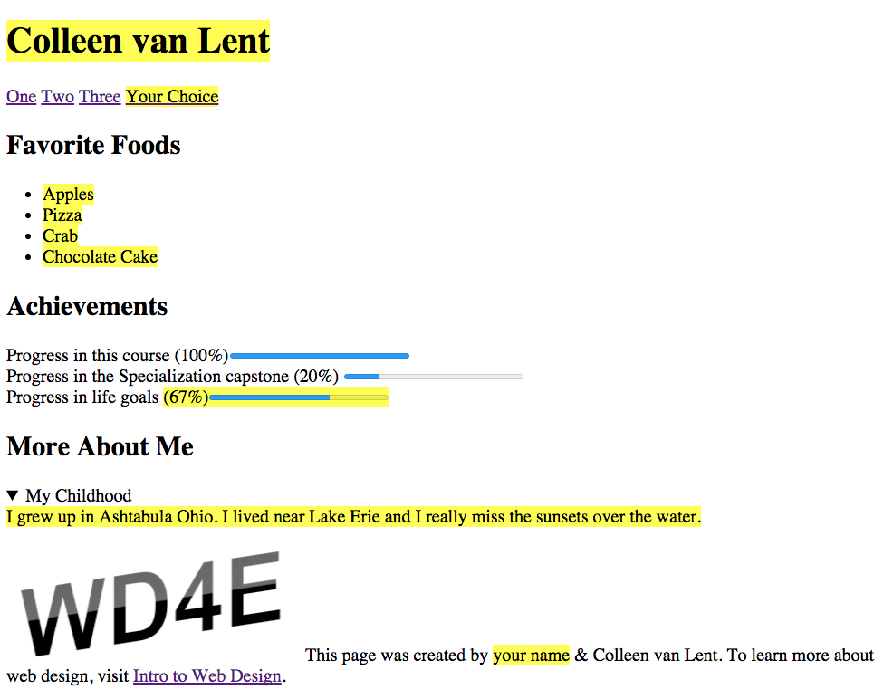

Grading Checklist

1. **doctype**
2. **head**
3. **body**

* **nav -- add four link, they can go to anywhere you like or nowhere at all**
* **section - Favorite Foods**
* **section - Achievements**
* **section - More About Me**

4**. footer - The image from the footer can be found at my website:**<http://www.intro-webdesign.com/images/newlogo.png>

Autograder

I have created an autograded that will check your HTML code for syntactics correctness (as well as spelling). Once you have completed that, you can put the entire file into the grader. Please note that you must get this COMPLETELY correct to receive credit. You will get frustrated. You will put in silly mistakes. But hang in there. And don't forget to reach out for help if you need it.